A/ LOGIN TEST
Test Admin Login

Username: adminfinal
Password: 123456

Expected:
Redirect to Dashboard
Console shows: ROLE LOADED: admin
Credentials appear
Update button appears
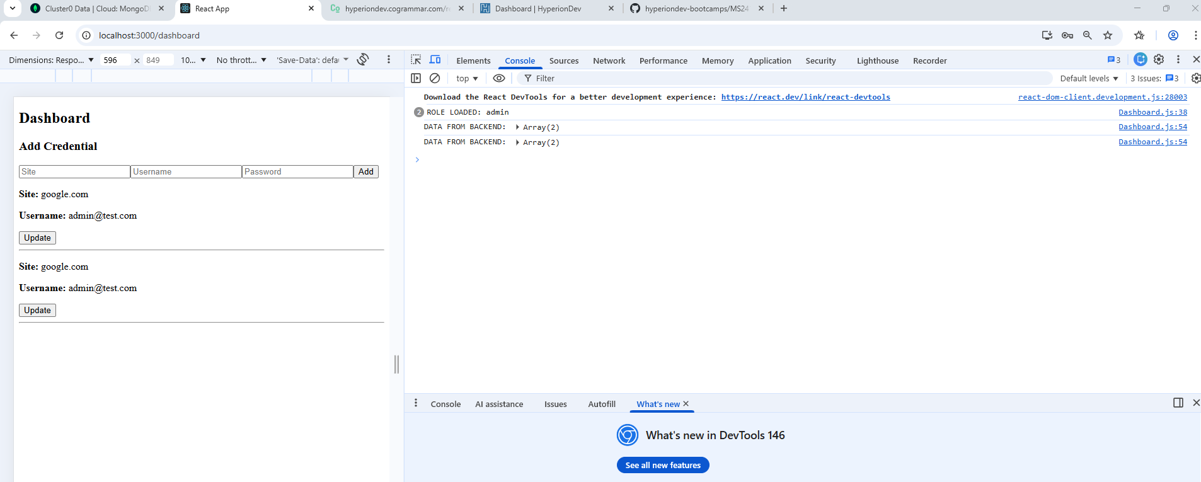
####################################
B/ ADD CREDENTIAL TEST
On Dashboard:
1. Enter:
Site: facebook.com
Username: fb@test.com
Password: 123456

2. Click 'Add'
Expected:
Alert: credential added successfully
Page reloads
New credentials appear in the list
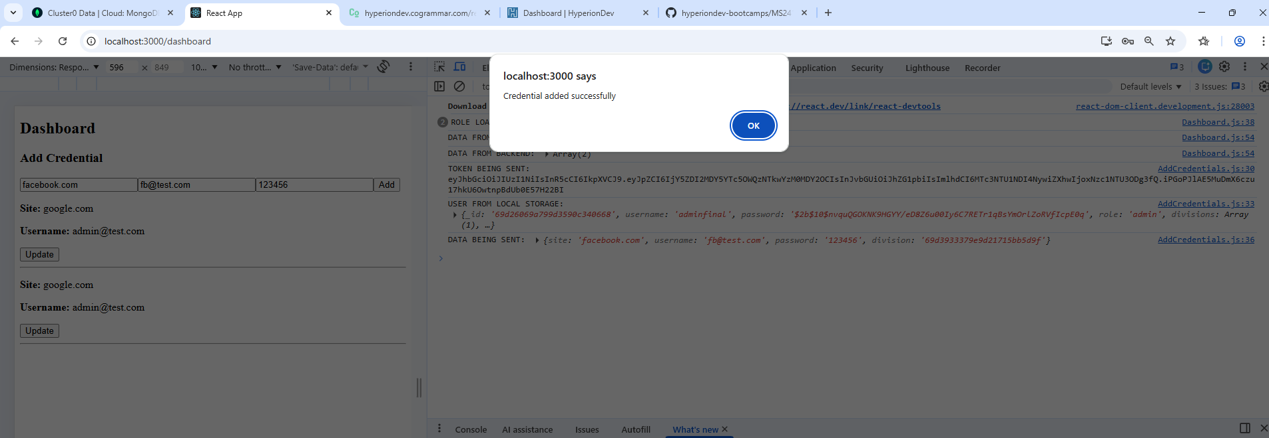
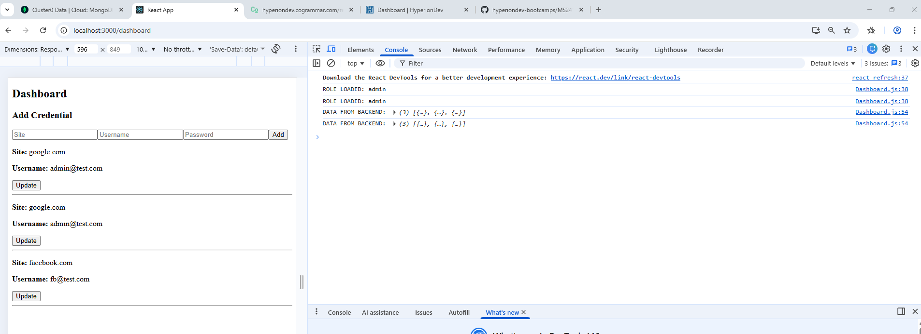
####################################
C/ UPDATE BUTTON TEST
Click Update
User must see:
Pop-up Enter new site:
Pop-up Enter new username:
Pop-up Enter new password:

Example input:
Site: google-update.com
Username: updated@test.com
Password: 999999

Expected:
Alert: Updated successfully
Page reloads
Credential shows updated values
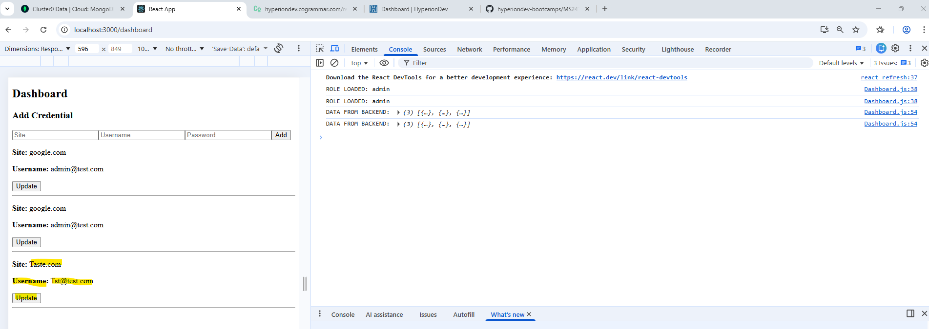
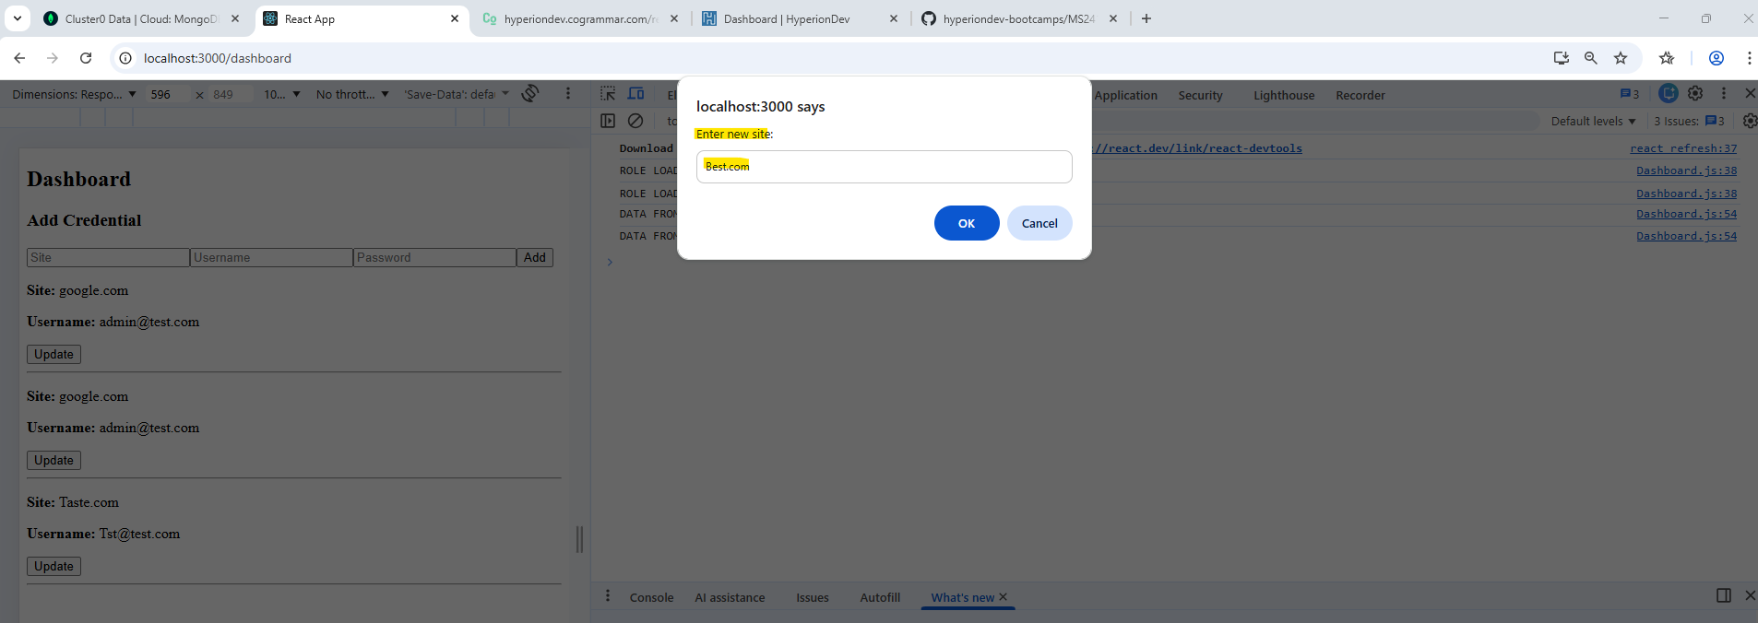

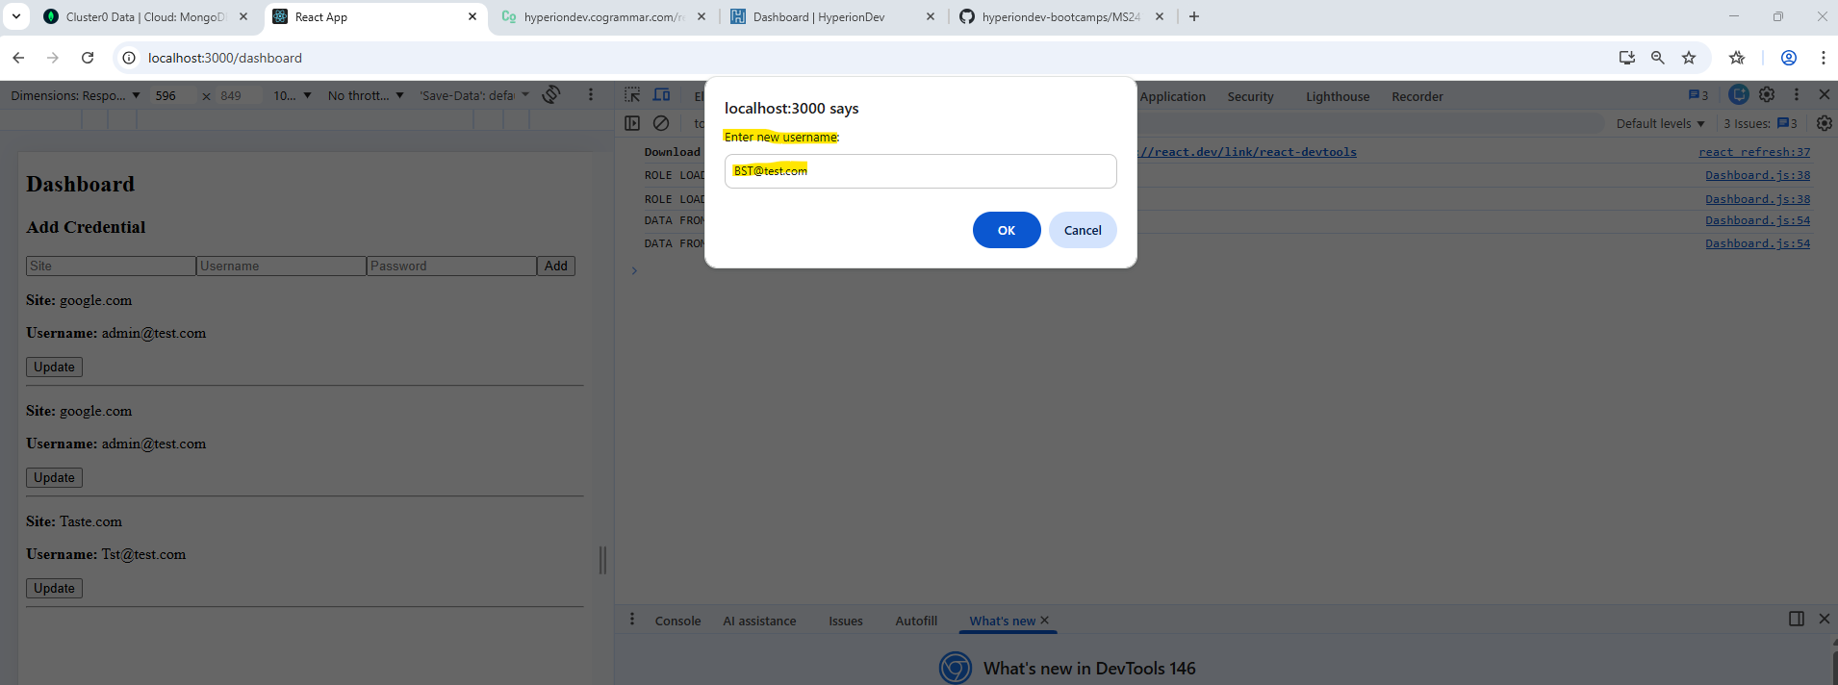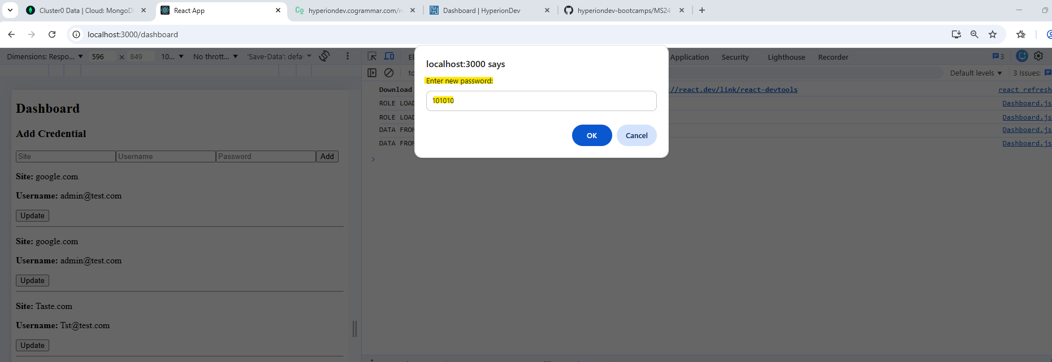

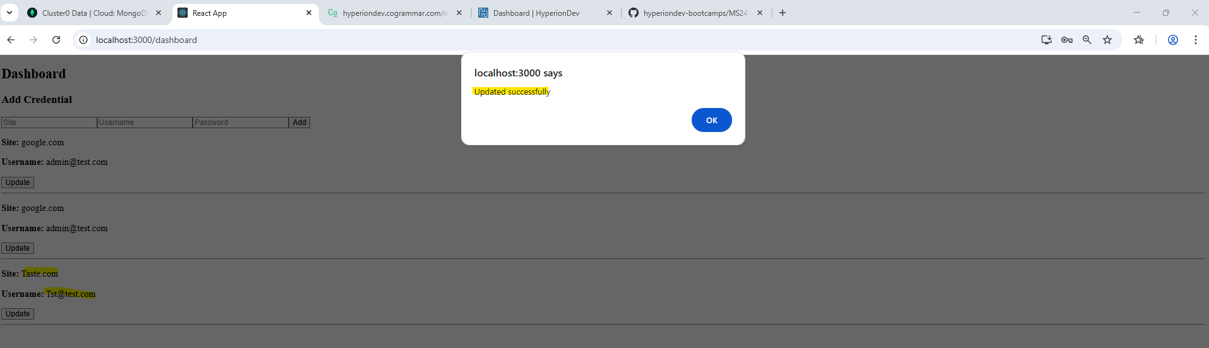
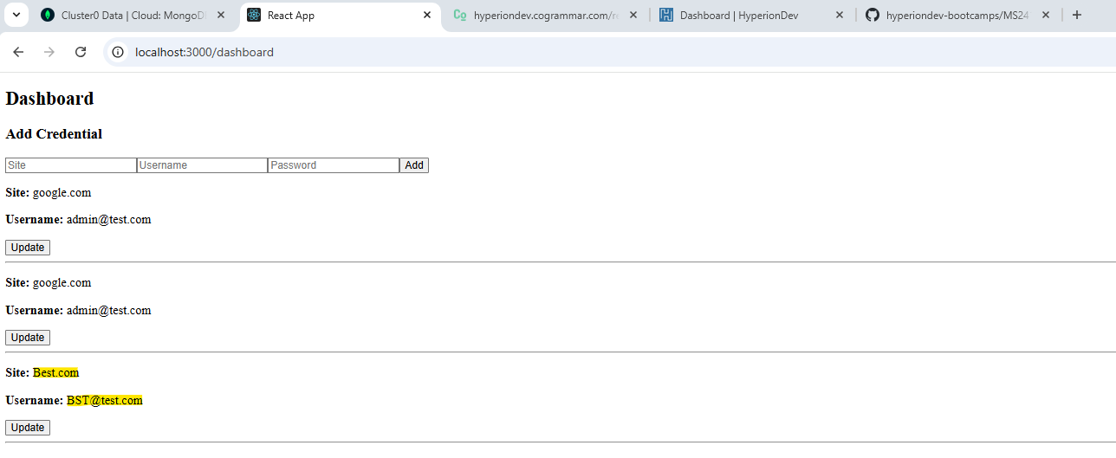
####################################
Test:
Dashboard: leave Credentials empty or complete only one part.

Result
Must get pop-up message “All fields are required”

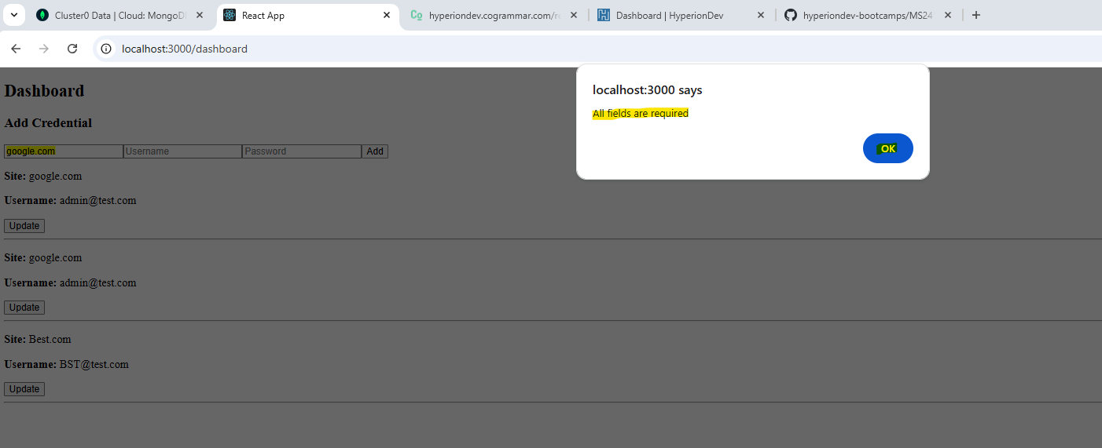
####################################
D/ ROLE-BASED ACCESS TEST (Critical)
Admin (adminfinal)
Should:
See credentials
Add credentials
See Update button
Update credentials

Normal User (create a test) REGISTER
Register a user:
Username: user88
Password: 123456

Then login: With the new user details
Username: user88
Password: 123456
Expected:
credentials visible (must be filtered by division)
NO UPDATE BUTTON
can add credentials

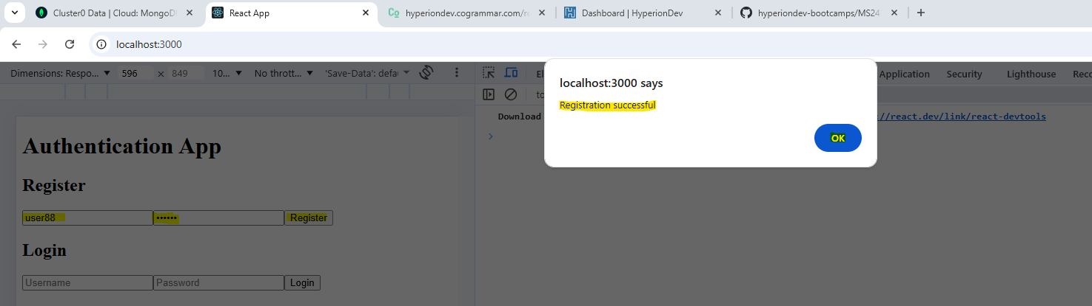

Test:
logged in as a normal user
Username: user1
Password: 123456
Result:
Expected:
credentials visible (must be filtered by division)
NO UPDATE BUTTON
can add credentials



